DIE# 15398A (Mini) – Anlin (EXTRUDER SIDE)
Pack on Green Mini Buggy – Wrap arms in cardboard
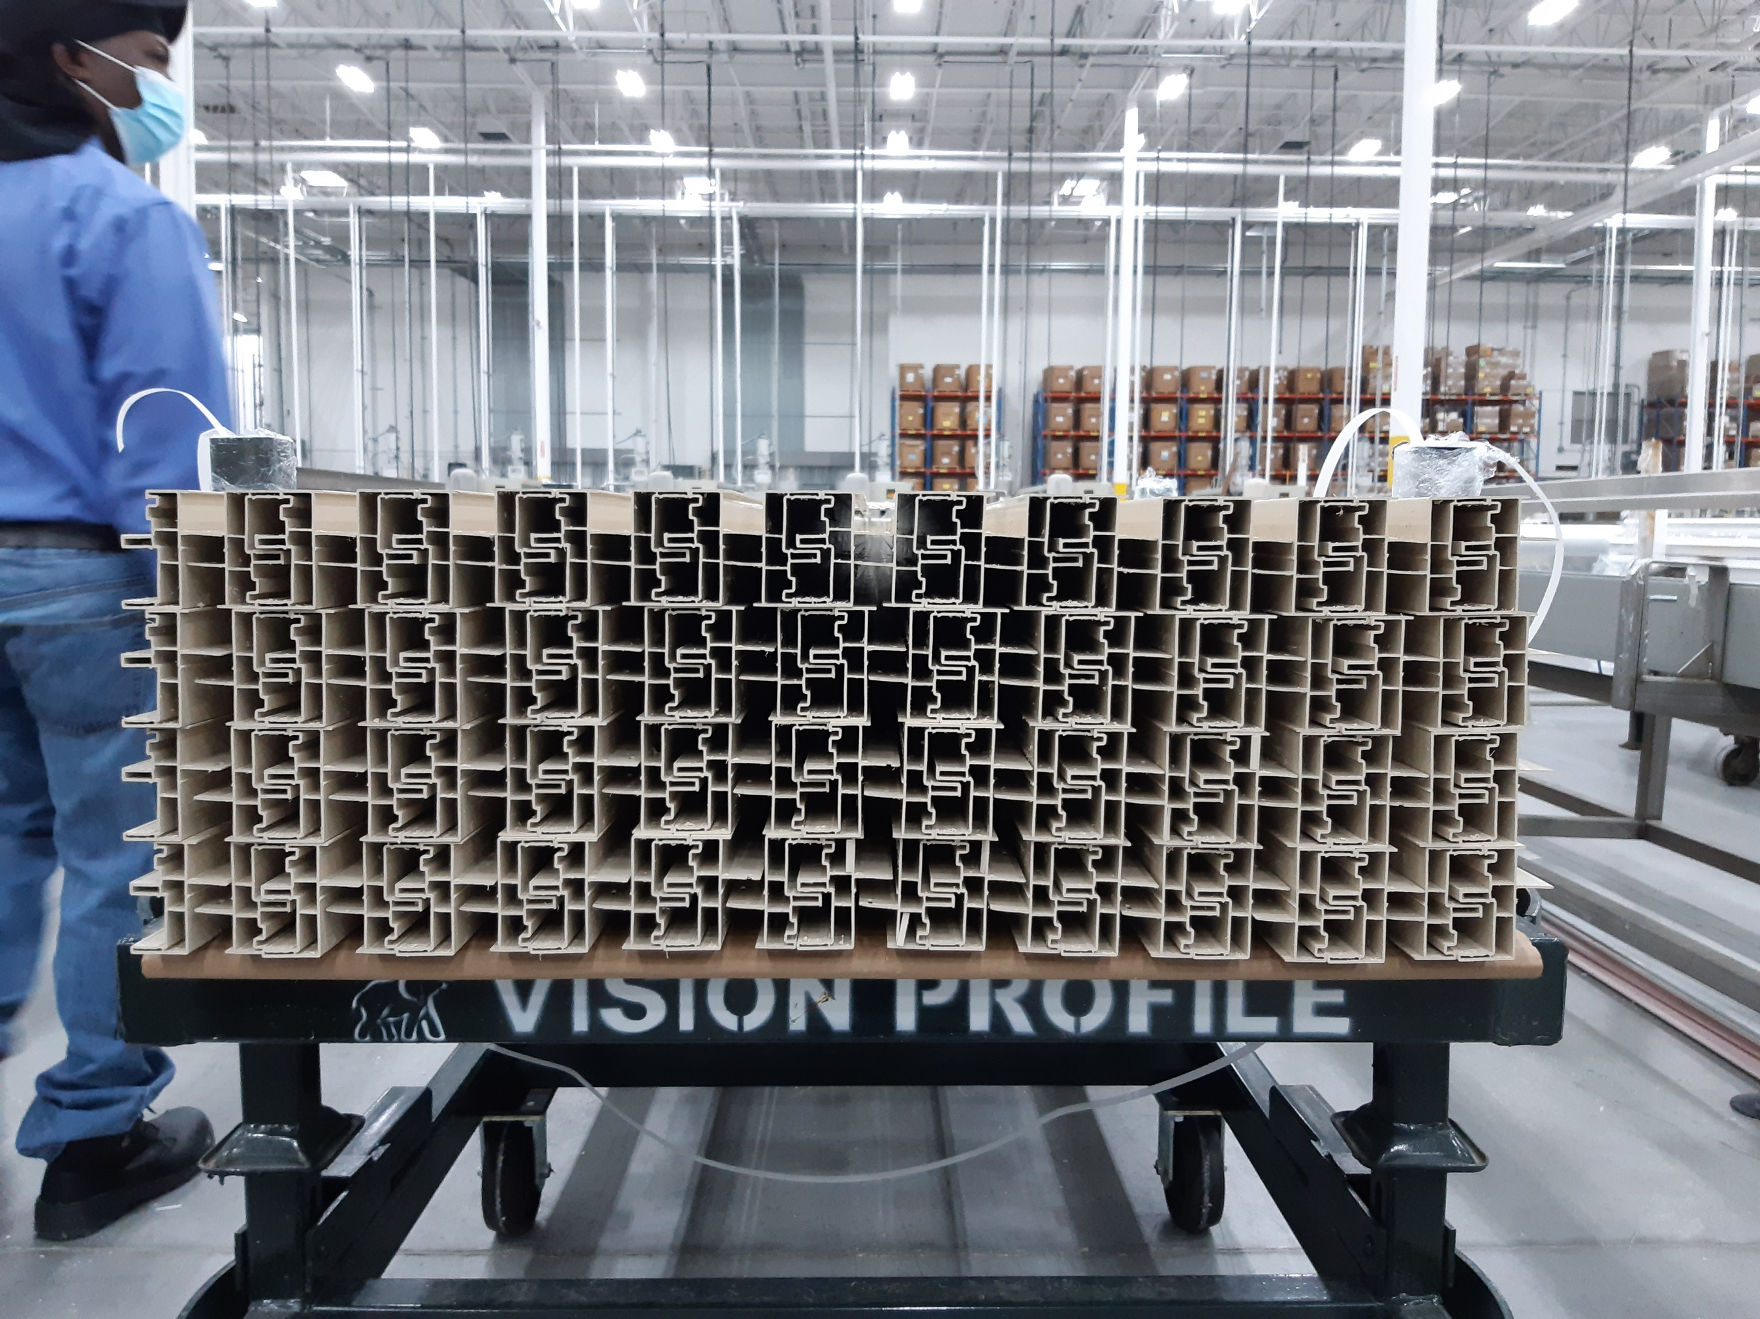
No Foam

